**FPT ACADEMY INTERNATIONAL**



## FPT – APTECH COMPUTER EDUCATION

NailArt

|  |  |  |  |
| --- | --- | --- | --- |
| **Center Name** | | FPT – Aptech – HCM2  Address: 590 Cach Mang Thang Tam, District 3, Ho Chi Minh City | |
| **Instructor** |  | Ms. Le Mong Thuy |  |
| **Class** |  | T1.2109.E0 |  |
| **Group** |  | 3 |  |
| **Group members** | | **Name** | **Student ID** |
|  |  | Nguyễn Hoàng Quân | Student1328433 |
|  |  | Lê Văn Trường | Student1333966 |
| **Duration** | Start date | 22-Nov-2021 |  |
| End date | 22-Dec-2021 |  |

**This is to certify that**

**Mr.:**

Nguyễn Hoàng Quân

Lê Văn Trường

**has successfully designed & developed**

eProject: NailArt

**Submitted by:**

Nguyễn Hoàng Quân

**Date of issue:**

**Authorized Signature:**



**TABLE OF CONTENTS**

FPT – APTECH COMPUTER EDUCATION 1

ACKNOWLEGMENT 4

SYNOSIS 4

PROBLEM DEFINITION 5

CUSTOMER'S REQUIREMENTS SPECIFICATIONS (CRS) 6

Business/Project Objective: 6

Hardware/ Software Requirements: 7

SCOPE OF THE WORK (IN BRIEF) 8

Architecture and design of the system 9

Diagram of the website 10

TASK SHEET REVIEW 1 11

SITE MAP 12

MOCK OF THE WEBSITE 13

TASK SHEET REVIEW 2 21

WEBSITE DESCRIPTION 22

TASK SHEET REVIEW 3 27

# ACKNOWLEGMENT

On behalf of all the members of group 3, I would like to thank you all for the hard works, supports to make this eProject complete successfully. Especially, Ms. Le Mong Thuy, our teacher, she helped us a lot from the day that we started to study at FPT Aptech. With this eProject, she has guided us with her enthusiasm and rigorous, because of her guiding, we would be able to finish this project. Besides, I want to thank all the team member of group 3, each of the team member has been working in order to complete this project. The last but not least, we would like to say thank you to our family for always supporting us, creating the best conditions for us to focus on the project, and putting faith in the dreams we pursue.

# SYNOSIS

Nail art is a creative way to paint, decorate, enhance, and embellish the nails. It is a type of artwork that can be done on [fingernails](https://en.wikipedia.org/wiki/Fingernails" \o "Fingernails) and [toenails](https://en.wikipedia.org/wiki/Toenails" \o "Toenails), usually after [manicures](https://en.wikipedia.org/wiki/Manicures" \o "Manicures) or [pedicures](https://en.wikipedia.org/wiki/Pedicures" \o "Pedicures). Manicures and pedicures are [beauty treatments](https://en.wikipedia.org/wiki/Beauty_salon" \o "Beauty salon) that trim, shape, and polish the nails. Often, these procedures remove the cuticles and soften the skin around the nails. Types of manicures can vary from polish on natural nails to dipping powder and acrylic nails.

The nail-care industry has been growing like never before ever since the invention of modern nail polish.

Nail art is also a way to create its own identity through fashion, using colours and shapes as a disruption of childhood and entering to the female teen/adult world, also leaving the influence of their parents to create their own selves.

Here we are aiming to design a website “NailArt” which will provide an easy way to learn nail art with various designs and steps involved.

.

# PROBLEM DEFINITION

The Web site is to be created based on the following requirements.

1. The home page must describe the keywords or highlight the nail art designs with all navigation links defined.
2. The site should provide the brief information about nailart as from where it originated etc.
3. There should be a well designed menu with necessary sub menu options.
4. There should be various categories (forms and styles) like easy to design for kids, complex for elders.
5. There should also be categories of designs as Faces, geometric design, flowers etc. Minimum 5 categories are expected here.
6. Proper description of the design along with the image and steps must be added in the website.
7. Along with the nailart designs there should be a section which will showcase the various products and accessories for art like nail polish etc
8. Also there should be a section giving information about nail care.
9. About Us
10. Contact us page: contact us details with location should be displayed using GeoLocation API (eg. GoogleMaps).
11. Feedback form
12. Gallery section should be added.
13. Color combination must be uniform throughout the project.
14. Navigation must be smooth.

# CUSTOMER'S REQUIREMENTS SPECIFICATIONS (CRS)

**Client: Mr. Aptech**

### Business/Project Objective:

The Objective of this program is to give a sample project to work on real life projects. These applications help you build a larger more robust application.

The objective is not to teach you JavaScript/Dreamweaver but to provide you with a real life scenario and help you create basic applications using the tools.

You can revise the chapters before you start with the project.

This project is meant for students who have completed the module of *HTML5*. These programs should be done in the Lab sessions with assistance of the faculty if required.

It is very essential that a student has a clear understanding of the subject. Students should go through the project and solve the assignments as per requirements given.

Kindly get back to eProjects Team in case of any doubts regarding the application or its objectives.

**Input to the system:**

* Filter a list of products for that user selected in product page.
* Leave user comments after browsing the web.

**Output from the system:**

* Display comments when the user clicks on our Review/Evaluation page.
* See nail art related products.
* See different nail styles like faces, geometric designs, flowers, holiday designs etc and those categories are divided into kids and adults.
* The history of nail art and nail art related changes and upcoming trends can be read.
* The collection will show everyone the wonderful works that have been made in the palm of your hand.
* Learn more about manicure and pedicure.

**Process**:

* Display the content that the user clicked on.
* Display information of nail art related products.

**Expected delivery date:**

20-12-2021

**List of deliverables:**

* + - * Document Word.
      * User Guide.
      * Source code.

# Hardware/ Software Requirements:

**Hardware**

* A minimum computer system that will help you access all the tools in the courses is a Pentium 166 or better
* 64 Megabytes of RAM or better

**Software**

* Notepad/HTML editor
* Dreamweaver
* IE 5.0/ Netscape 6.0

# SCOPE OF THE WORK (IN BRIEF)

After a long and detailed discussion, our group has decided to create a website contain the following webpages:

1. **Home page:** describe the keywords or highlight the nail art designs with all navigation links defined.
2. **Kinds of designs:** Faces, geometric design, flowers etc. For kids and adults.
3. **Product:** Various art products and accessories like nail polish etc.
4. **About Us/Contact us:** About the members. Contact us details with location should be displayed using GeoLocation API (eg. GoogleMaps).
5. **History:** provide the brief information about nailart as from where it originated etc.
6. **Review/Evaluation:** Feedback form.
7. **Gallery:** Image
8. **Relate Knowledge**: The dangers of improper manicure.

# Architecture and design of the system

Webpage request



Requested Page

**RENDERING**

**ENGINE**

**CSS CODE**

**HTML CODE**

**WEB SERVER**

**WEB BROWSER**

**JS CODE**

**CLIENT**

**SERVER**

# Diagram of the website

Home

Product

Contact US

user

For Kids

About US

Relate Knowledge

History

Kind of Design

Gallery

For Adults



# TASK SHEET REVIEW 1

|  |  |  |  |  |  |  |  |
| --- | --- | --- | --- | --- | --- | --- | --- |
| **Project Ref. No.:**  **eP/Advertisement Portal Management**  **System/01** | | **Project Title:** | **Activity Plan Prepared By:** | **Date of Preparation of Activity Plan:** | | | |
| **Sr.**  **No.** | **Task** | **Actual**  **Start Date** | **Actual Days** | **Team**  **Mate Names** | **Status** |
| 1 | Problem Statement | NailAir | Nguyen Hoang Quan | 22-Nov-21 | 1 | Quan | Completed |
| 2 | Analysis requirements about the website | 22-Nov-21 | 1 | Quan | Completed |
| 3 | The scope of the work (in brief) | 22-Nov-21 | 1 | Quan | Completed |
| 4 | Architecture and design of the system | 22-Nov-21 | 1 | Quan | Completed |
| 5 | Diagram of the website | 22-Nov-21 | 1 | Quan | Completed |
| 6 | Task Sheet | 22-Nov-21 | 1 | Quan | Completed |

|  |  |
| --- | --- |
| **Date: 23-11-2021** | |
| Signature of Instructor:  **Ms. Le Mong Thuy** | Signature of Team Leader:    **Nguyen Hoang Quan** |

# SITE MAP

Home

Contact US

For Adults

For Kids

Product

About US

Relate Knowledge

History

Kind of Design

Gallery

# MOCK OF THE WEBSITE

1. **Homepage**

IMAGE WEBSITE

LOGO – MENU

Event

Info 6

Info 5

Info 4

Info-image3

Info-image2

Info-image1

Image3

Image2

Image1

CONTACT + INFORMATION NAILART

1. **Product Page**

CONTACT + INFORMATION NAILART

Info-image

IMG

Info-image

IMG

Info-image

IMG

Menu products

IMG

Info-image

IMG

Info-image

IMG

Info-image

Info-image

IMG

Info-image

IMG

Info-image

IMG

IMAGE WEBSITE

LOGO – MENU

1. **History**

LOGO – MENU

IMAGE WEBSITE

Footer

Paragraph

IMG

Paragraph

IMG

Paragraph

1. **Gallery page**

LOGO – MENU

Image-Grid

CONTACT + INFORMATION NAILART

1. **Kind of Design( Kids)**

IMG + info

IMAGE WEBSITE

LOGO – MENU

IMG + TEXT + LINK

CONTACT + INFORMATION NAILART

IMG + info

IMG + info

IMG + info

IMG + info

1. **Kind of design (adults)**

CONTACT + INFORMATION NAILART

IMG + info

IMAGE WEBSITE

LOGO – MENU

IMG + info

IMG + info

IMG + info

IMG + info

1. **Relate Knowledge**

CONTACT + INFORMATION NAILART

Menu

Content + IMG

IMAGE WEBSITE

LOGO – MENU

1. **Contact us**

CONTACT + INFORMATION NAILART

IMAGE WEBSITE

LOGO – MENU

Tel,email..

address

Google map, Address of Park

Support Center  
& Customer comment

1. **About Us (team infomation)**

Clip profile + info

Picture+info

CONTACT + INFORMATION NAILART

Picture+info

IMAGE WEBSITE

LOGO – MENU

# TASK SHEET REVIEW 2

|  |  |  |  |  |  |  |  |
| --- | --- | --- | --- | --- | --- | --- | --- |
| **Project Ref. No.:**  **eP/Advertisement**  **Portal**  **Management System/01** | | **Project Title:** | **Activity Plan Prepared By:** | **Date of Preparation of Activity Plan:** | | | |
| **Sr.**  **No.** | **Task** | **Actual Start Date** | **Actual Days** | **Team Mate Names** | **Status** |
| 1 | Site map | NailArt | Nguyen Hoang Quan | 26-11-2021 | 1 | Quan | completed |
| 2 | Mock of the website | 26-11-2021 | 1 | Quan+  Truong | completed |
| 3 | Task sheet | 26-11-2021 | 1 | Quan | completed |

|  |  |
| --- | --- |
| **Date:26-11-2021** | |
| Signature of Instructor:  **Ms. Le Mong Thuy** | Signature of Team Leader:  **Nguyen Hoang Quan** |

# WEBSITE DESCRIPTION

**Home-page:**

Description:

This webpage displays following information:common nail industry terms, Nail trends that "cause fever" around the world, holiday and contact.

Screenshoot

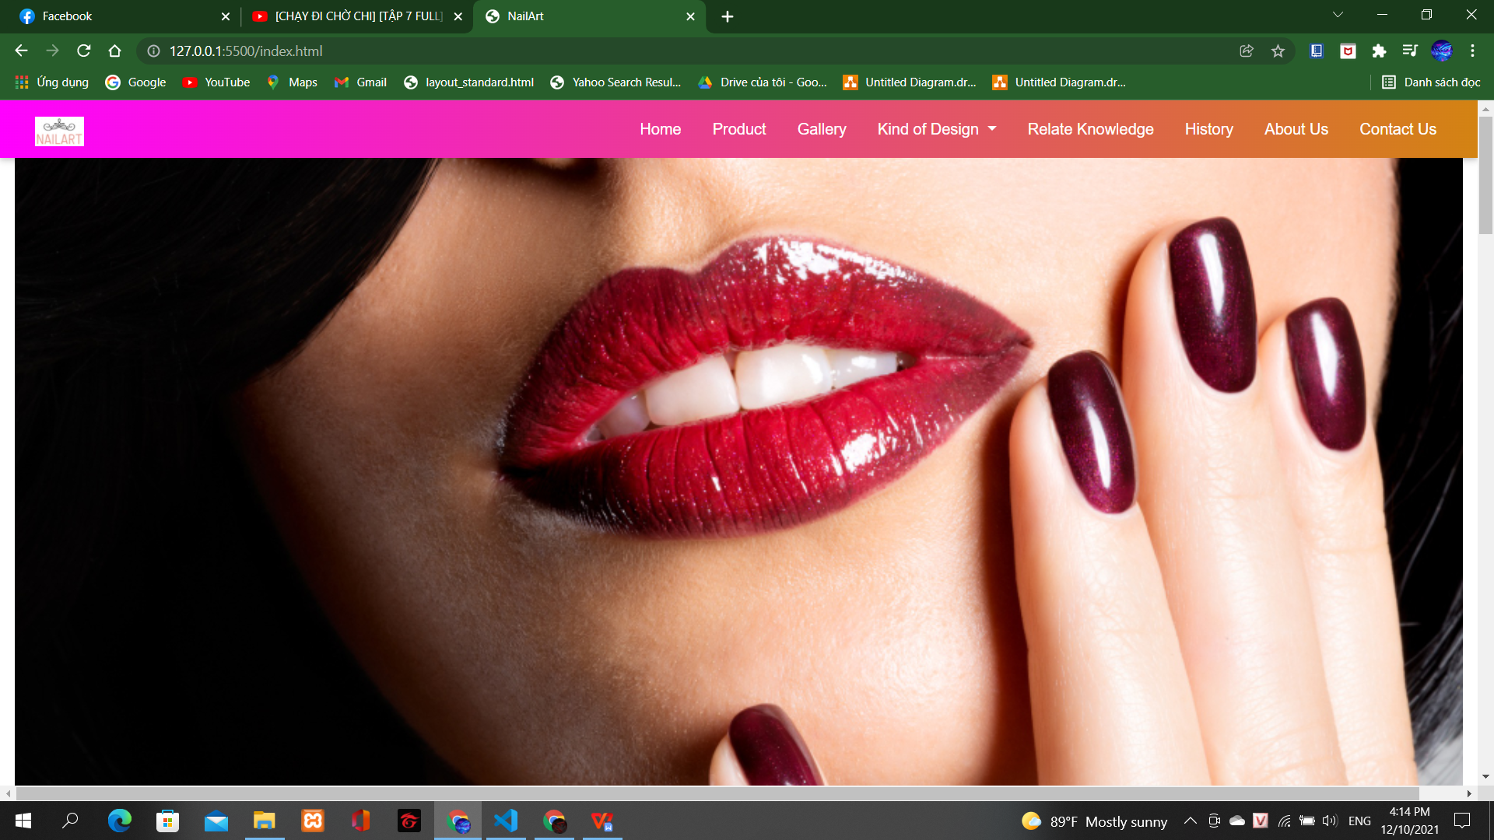

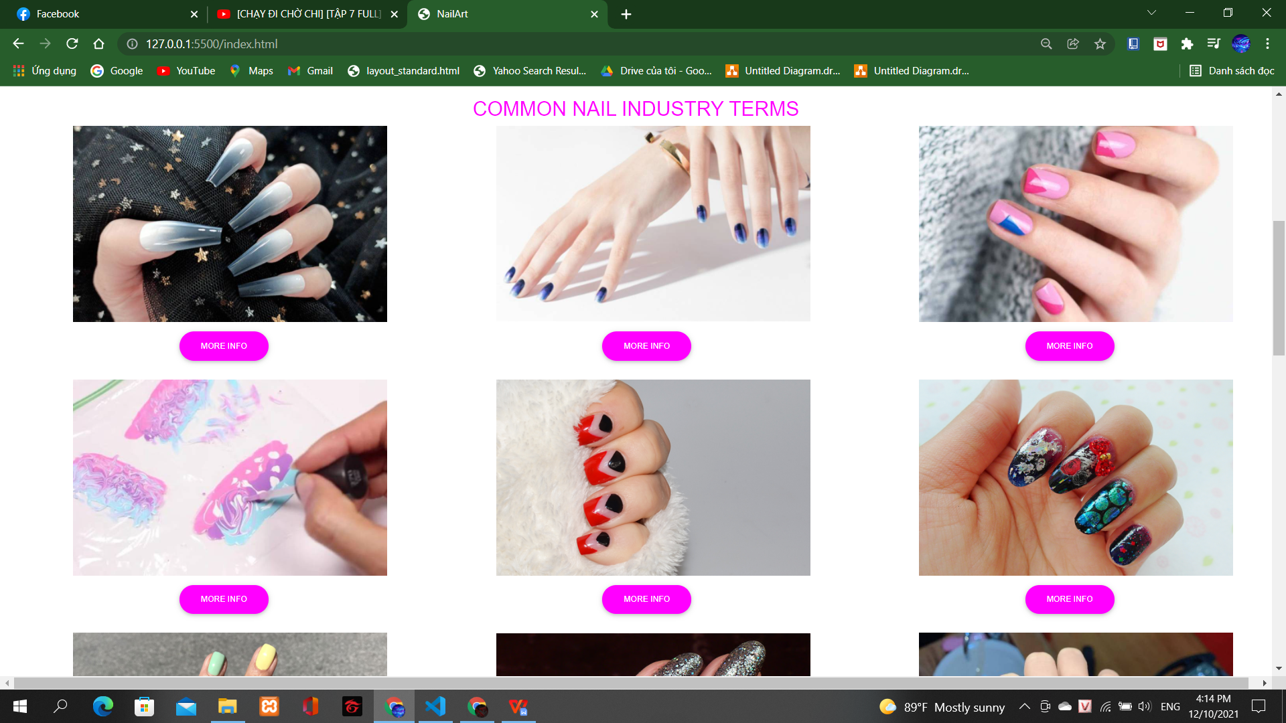

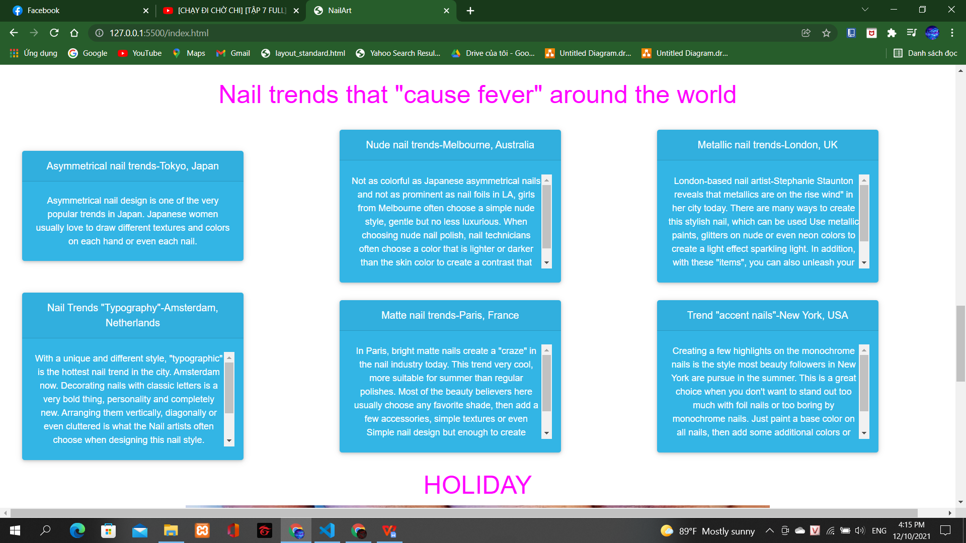

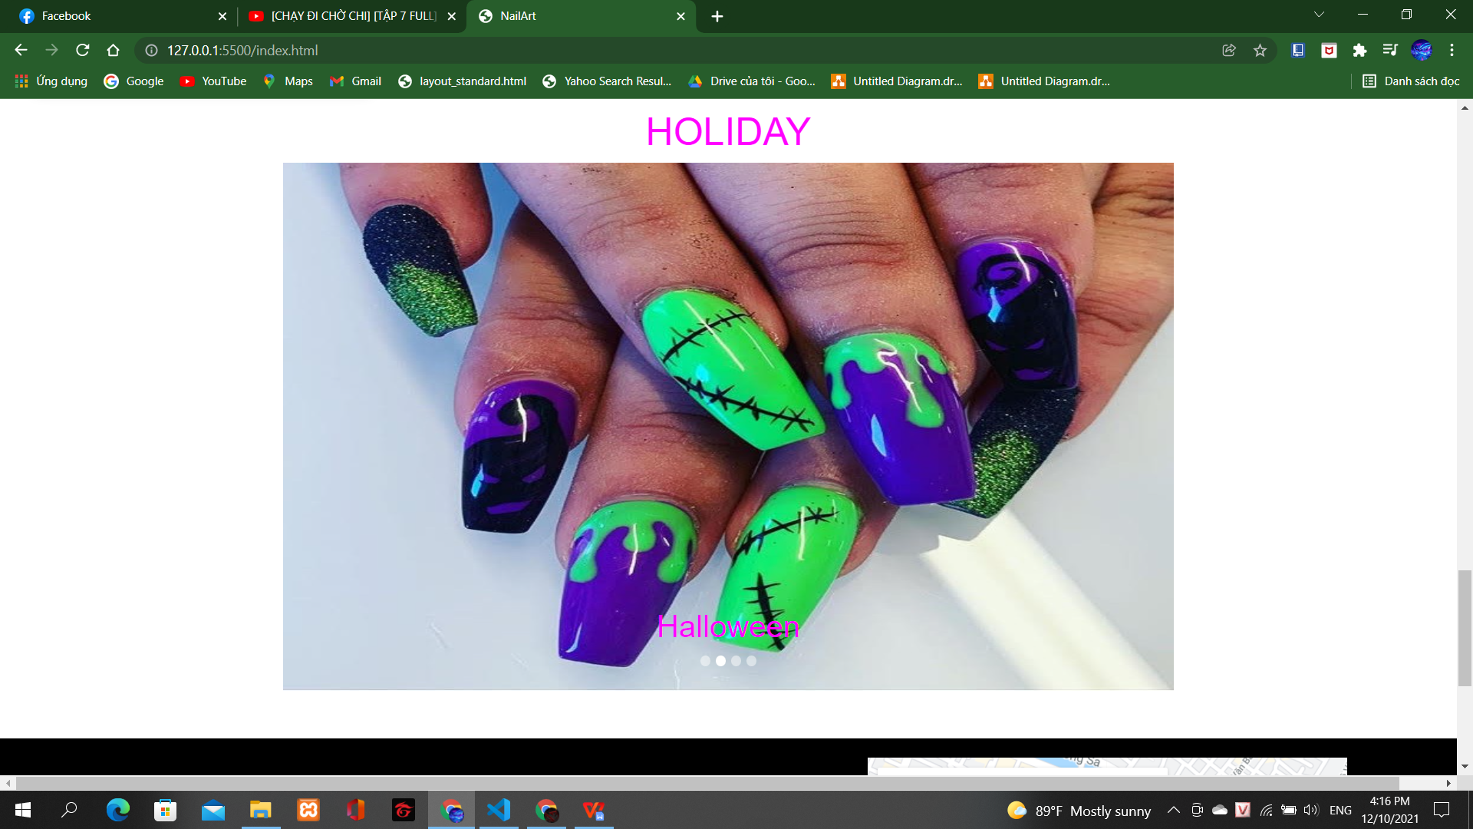

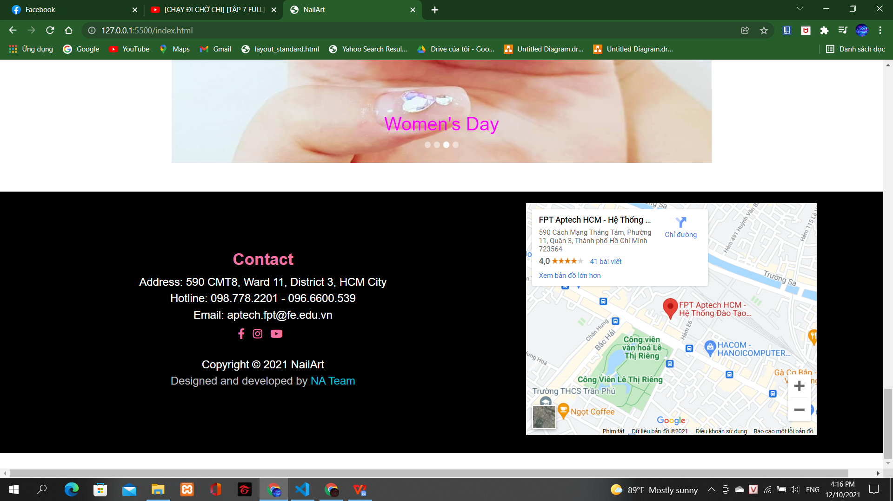

**Gallery-page:**

Description:

This webpage displays following information: beautiful photos and contact.

Screenshoot

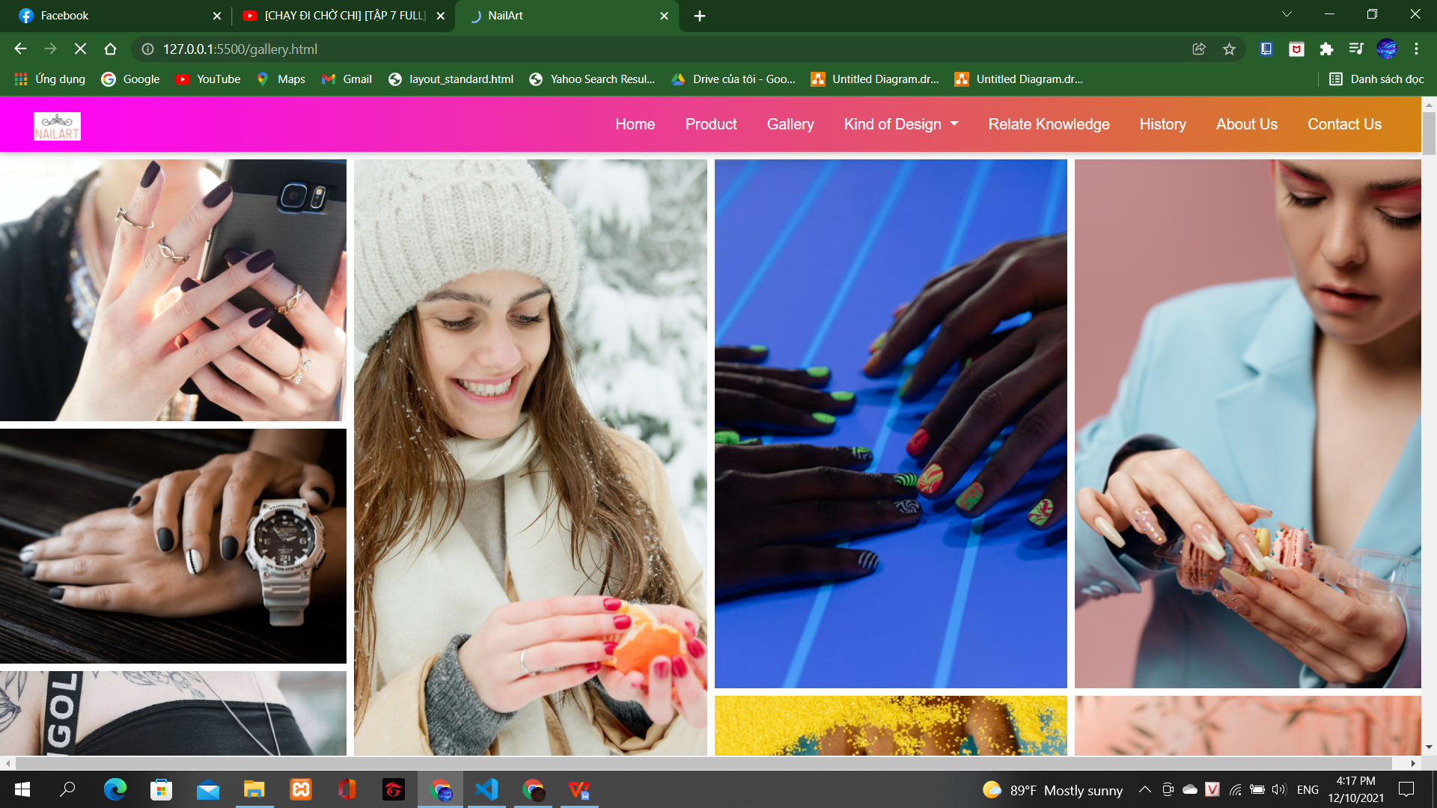

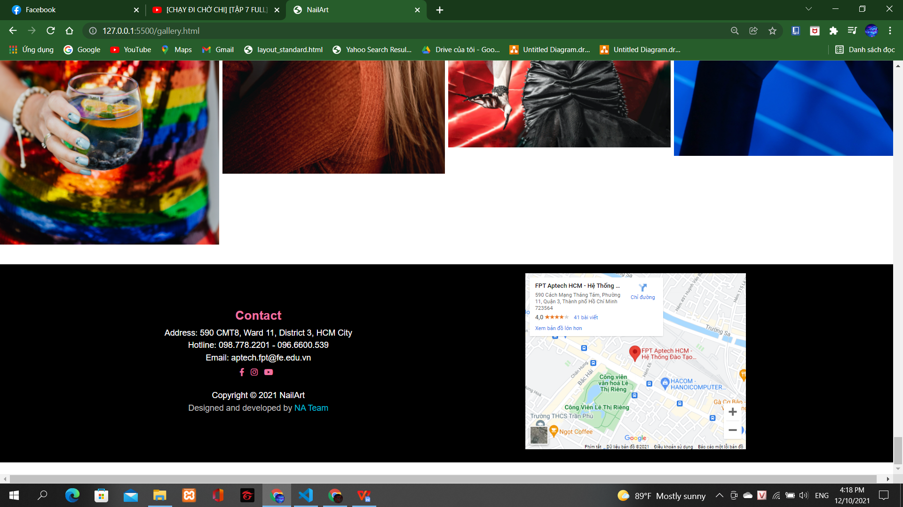

**History-page:**

Description:

This webpage displays following information: The origin of nail art, In popular culture, Social relevance, Media, Techniques and tools, Innovations, Notable nail artists and Contact.

Screenshoot

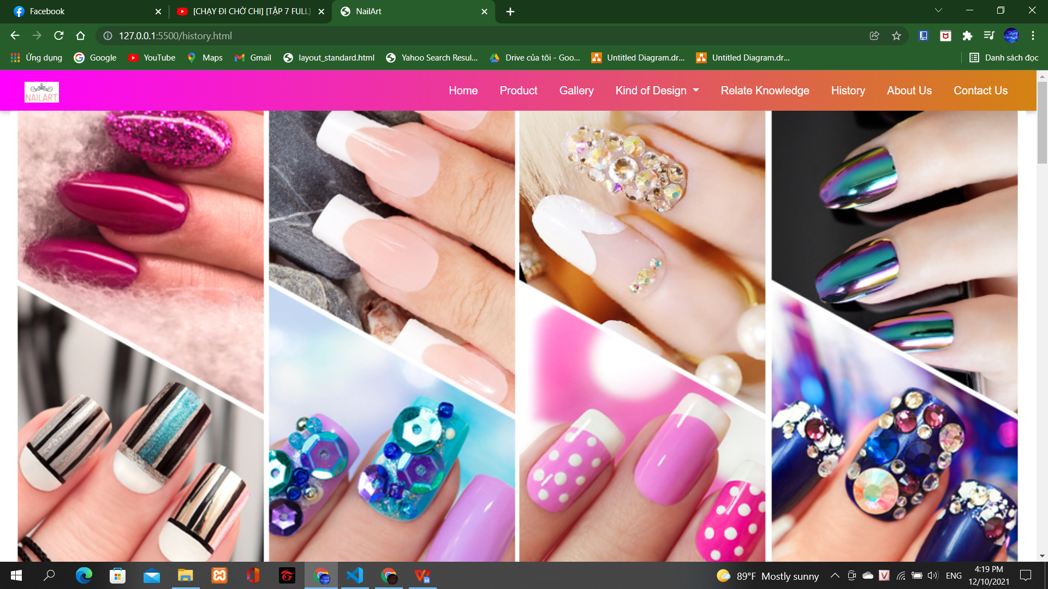

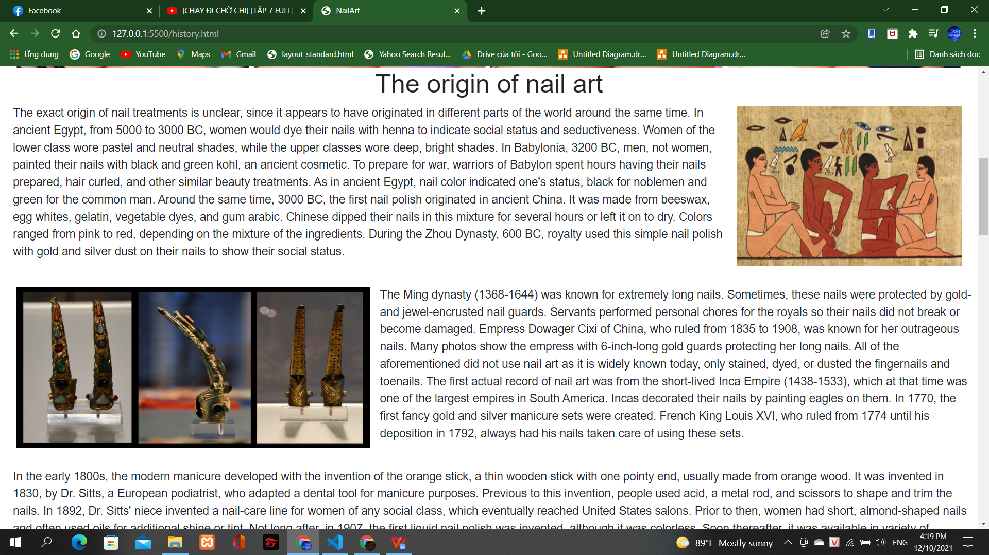

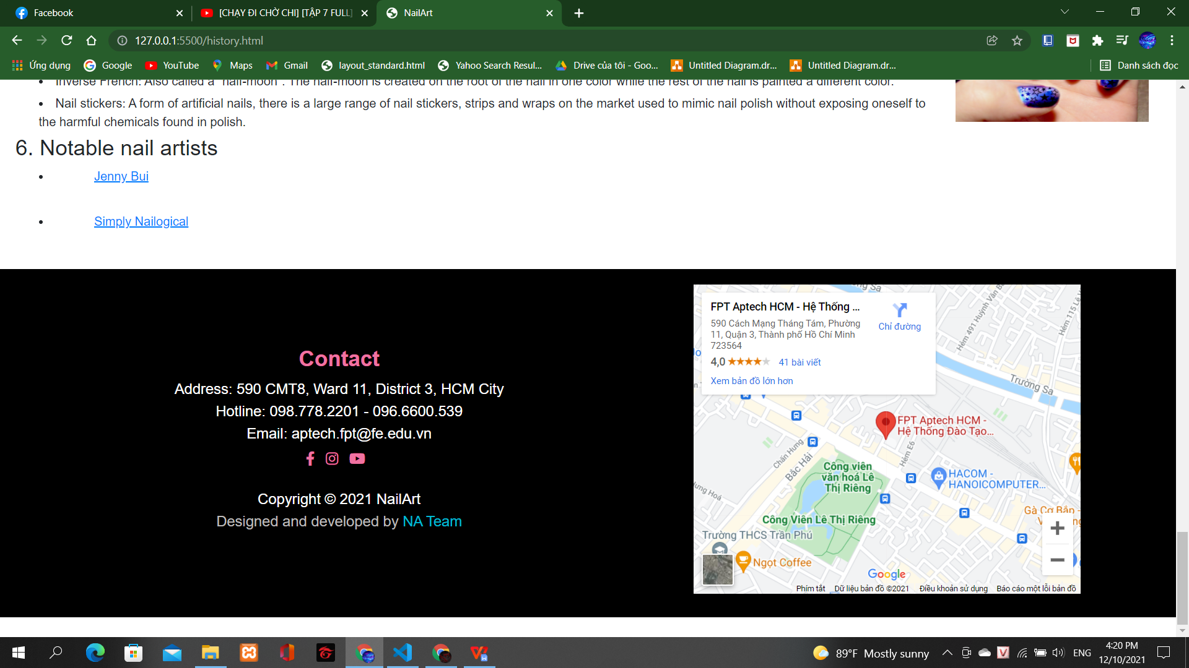

**About Us-page:**

Description:

This webpage displays following information:Profile about APTECH, our teams and Contact.

Screenshoot

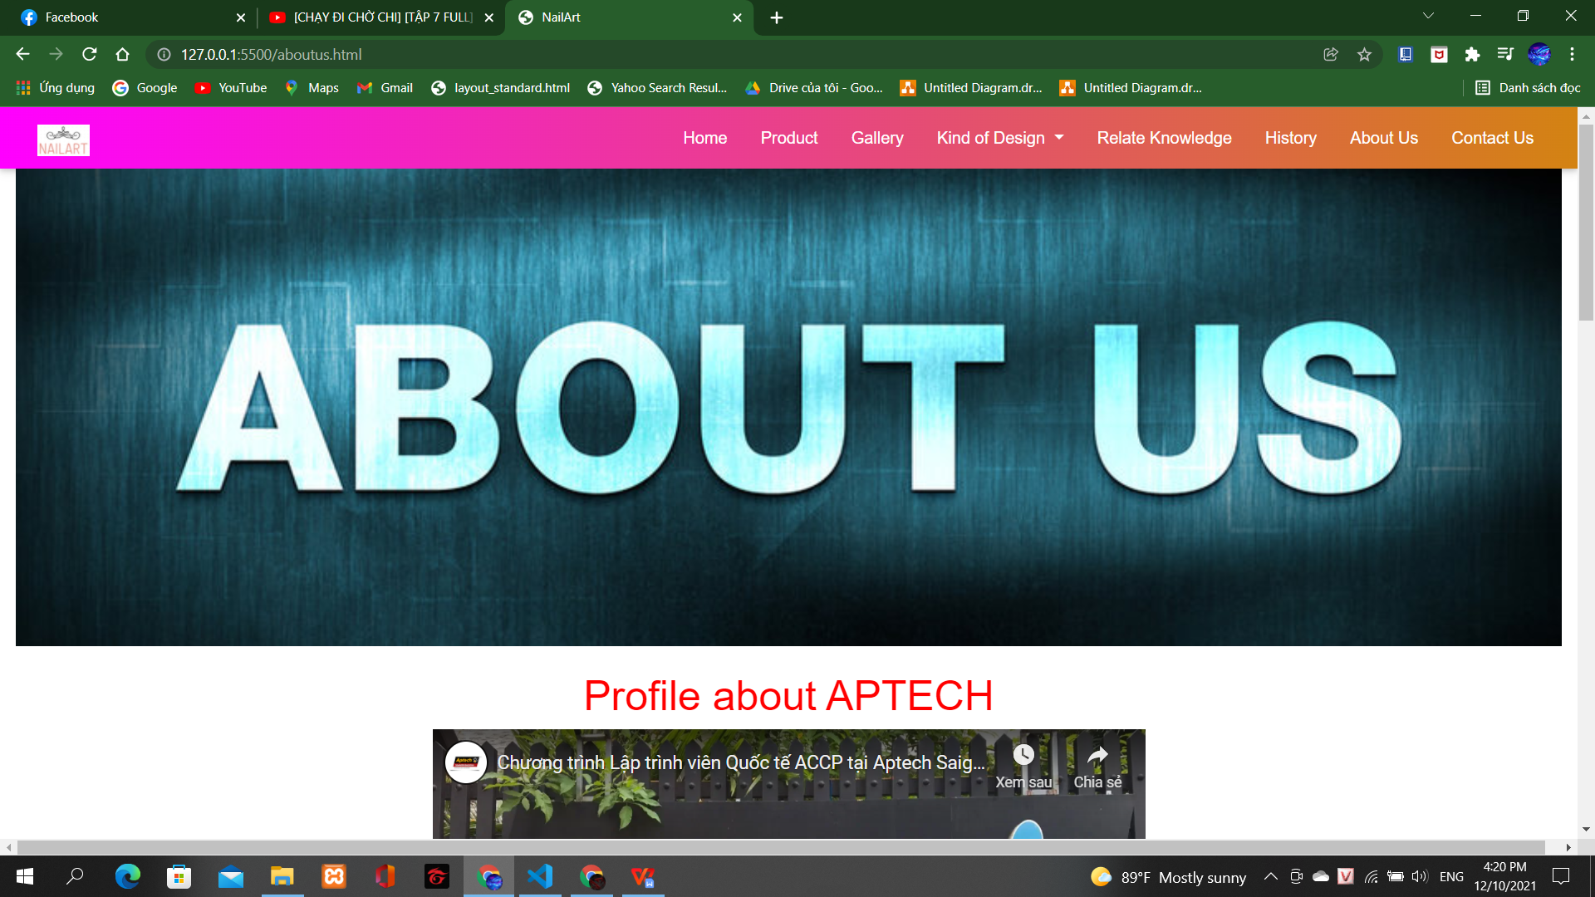

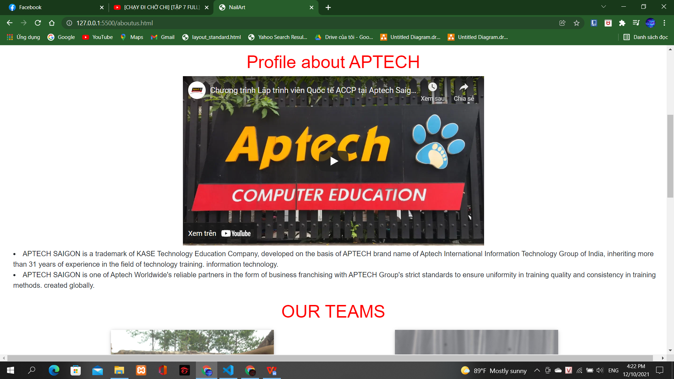

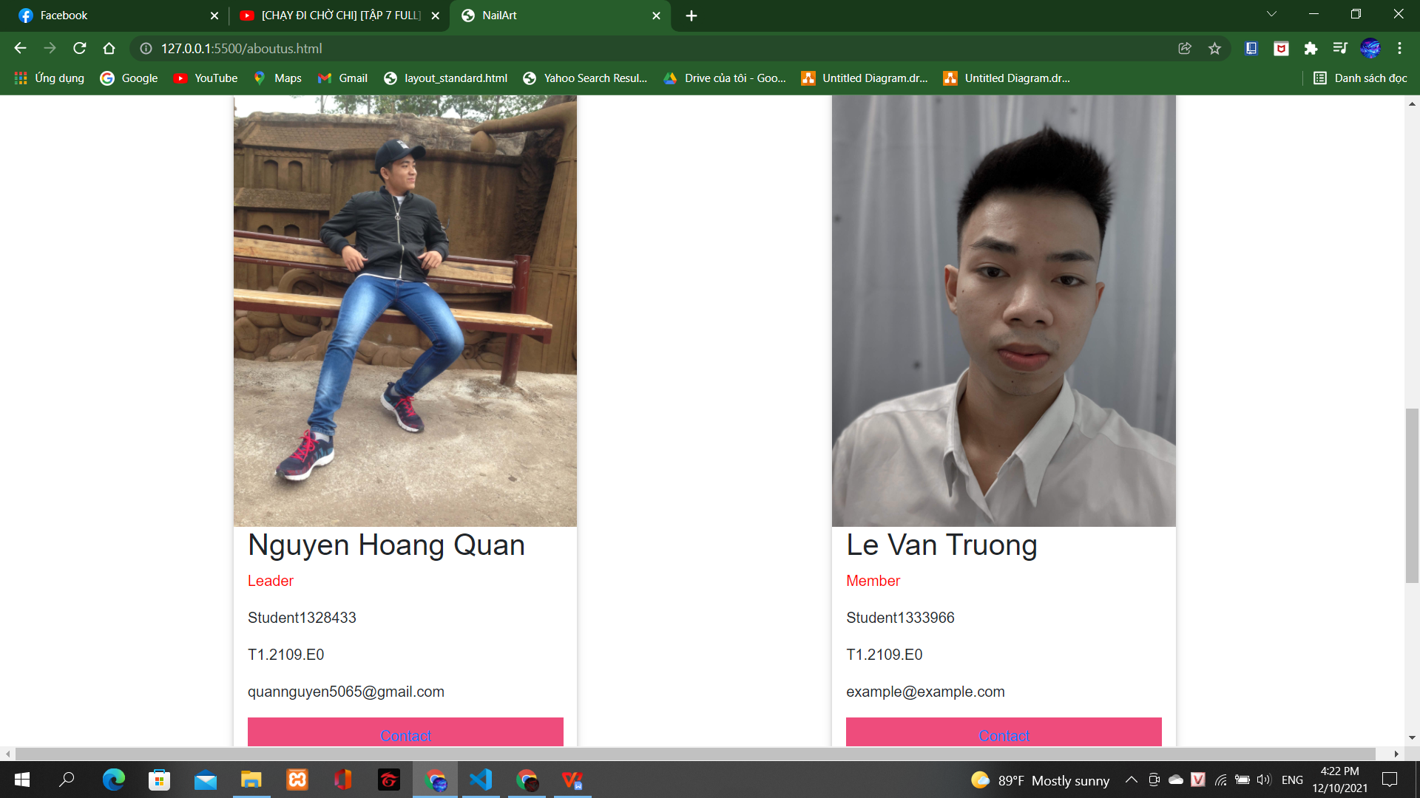

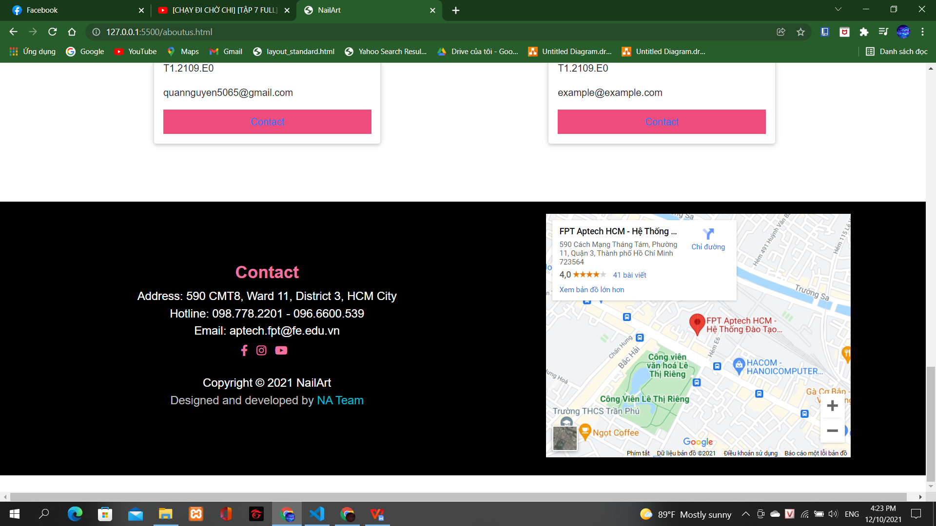

**Contact Us-page:**

Description:

This webpage displays following information:Contact information, Form Feedback, Map and Contact.

Screenshoot

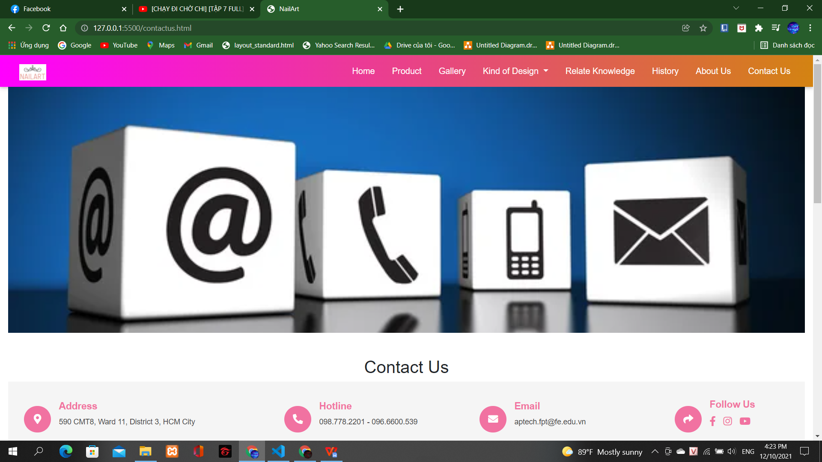

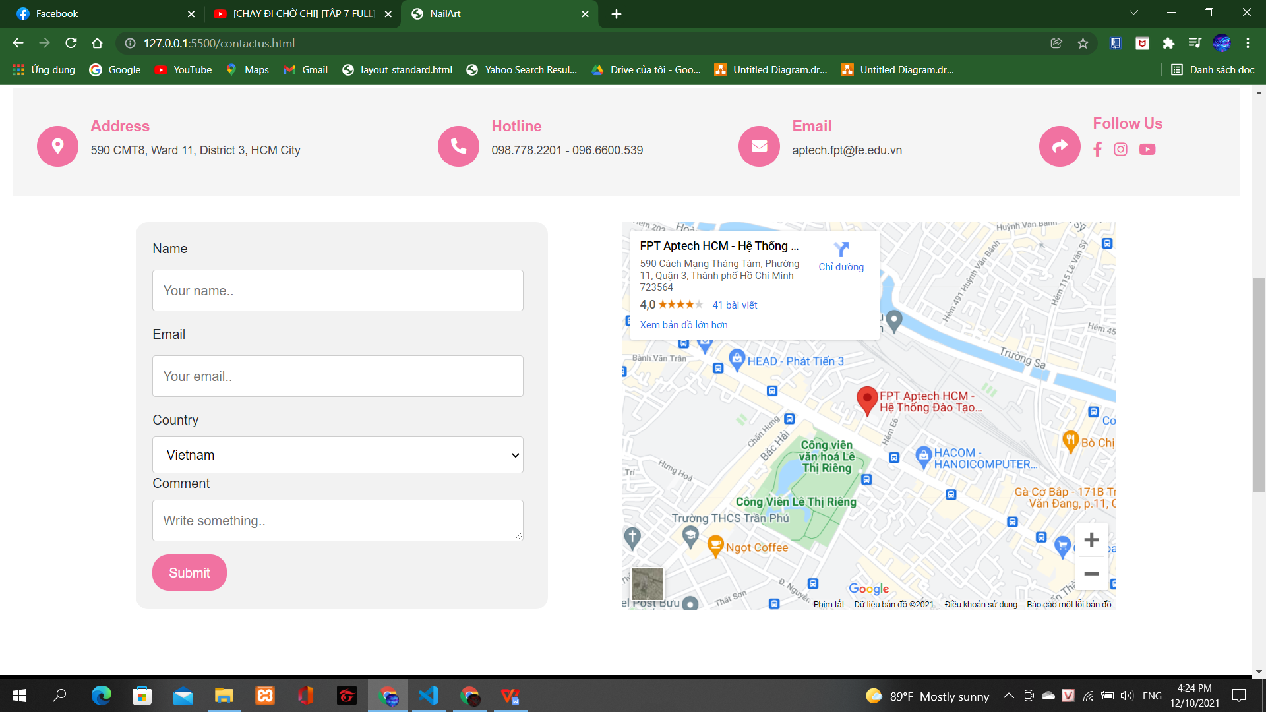

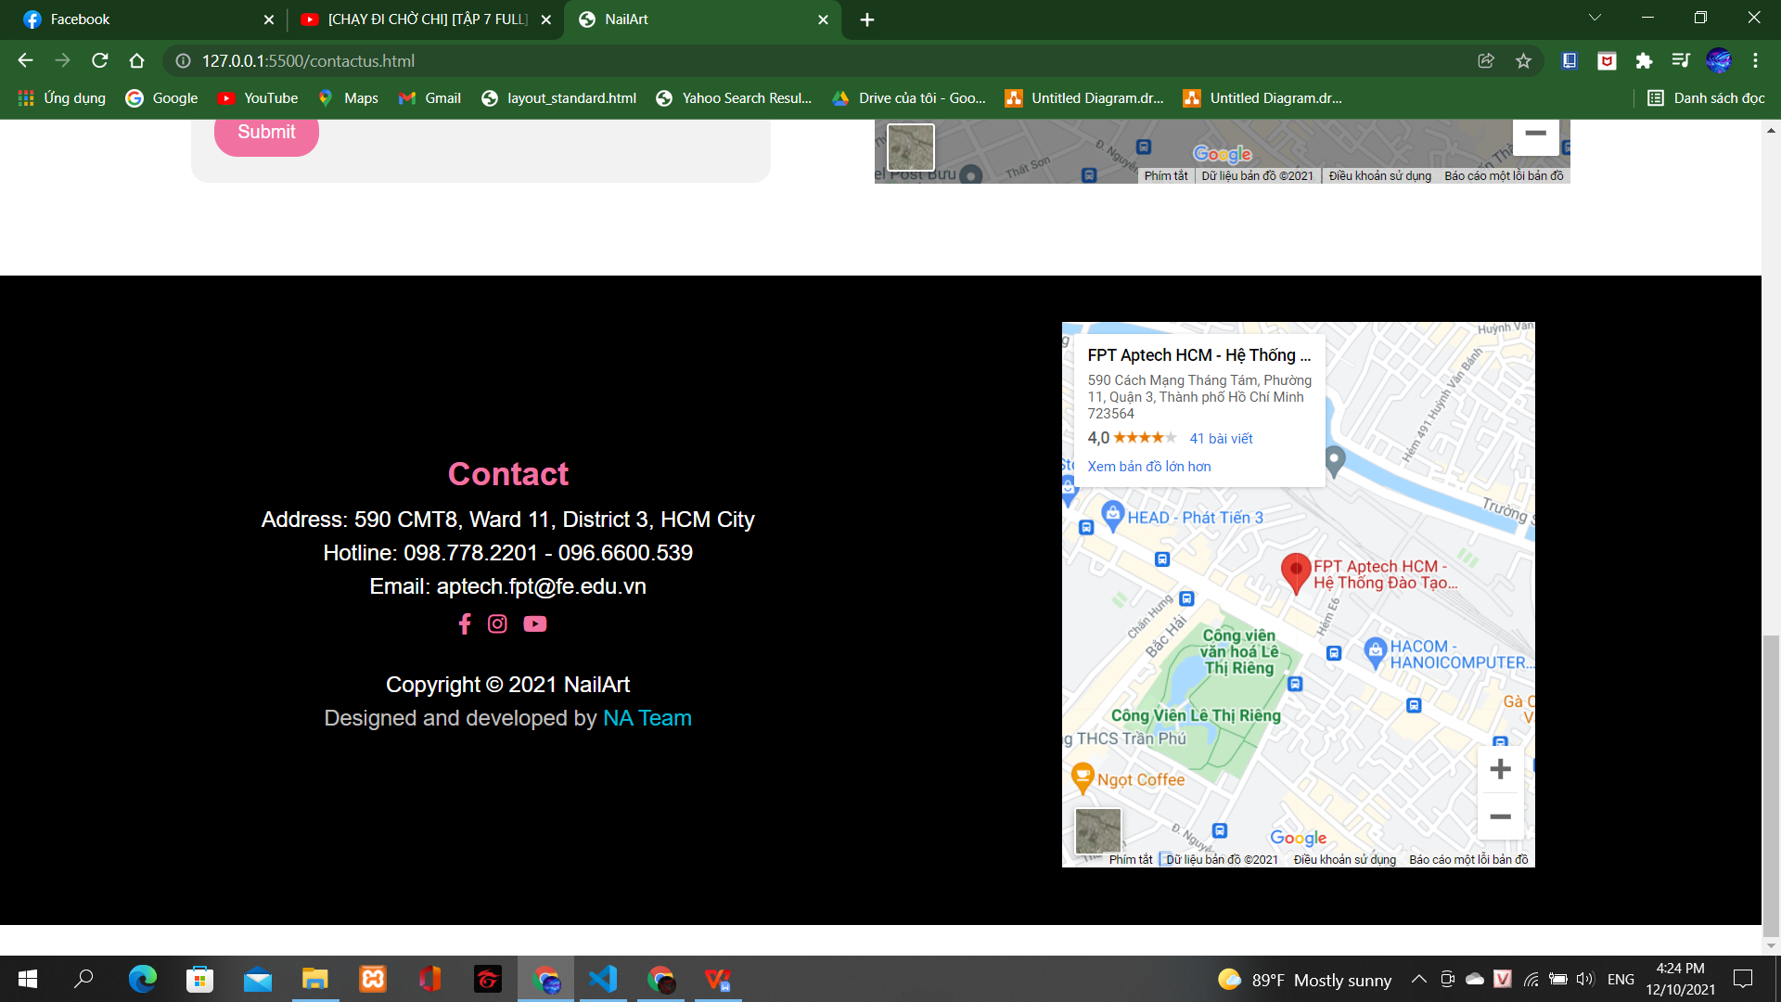

**Relate Knowledge:**

Description:

This website displays the following information: Maps and Contacts, and Related Needs to Know About Nails.

Screenshoot

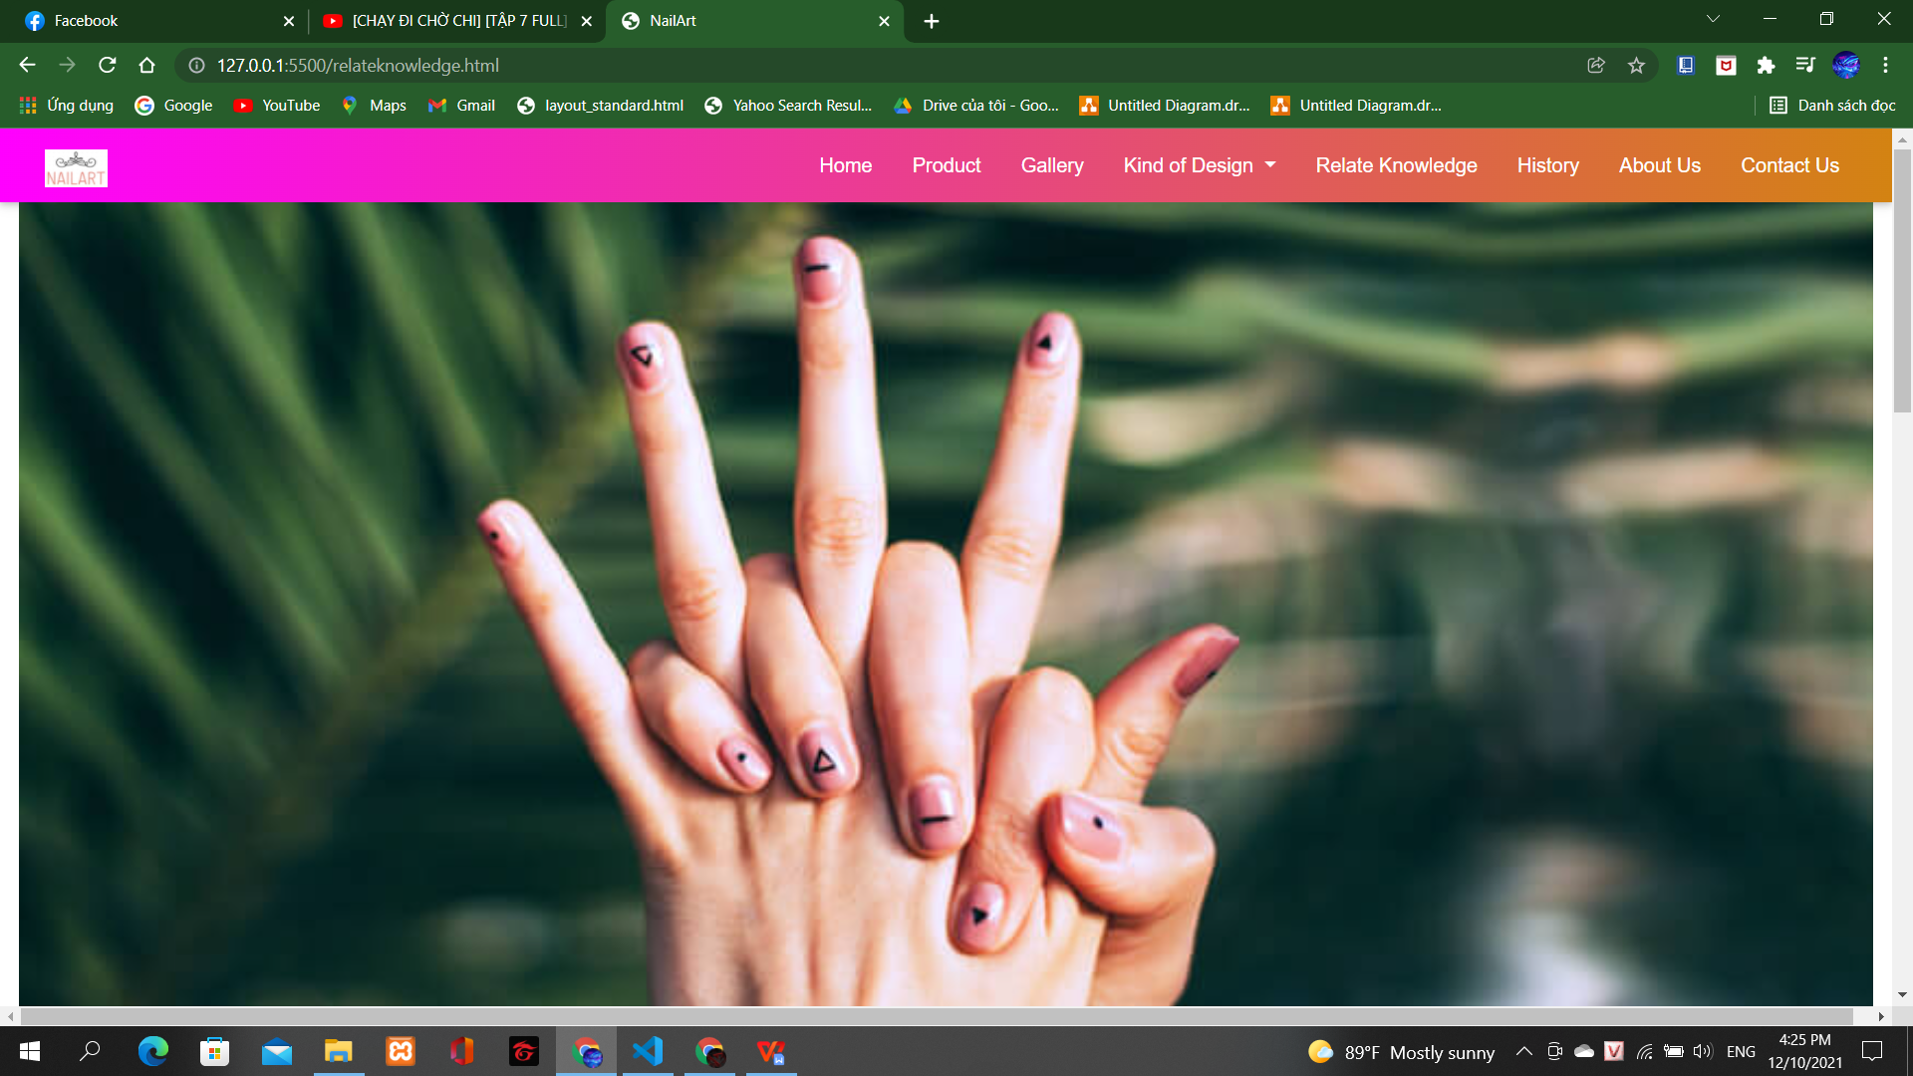

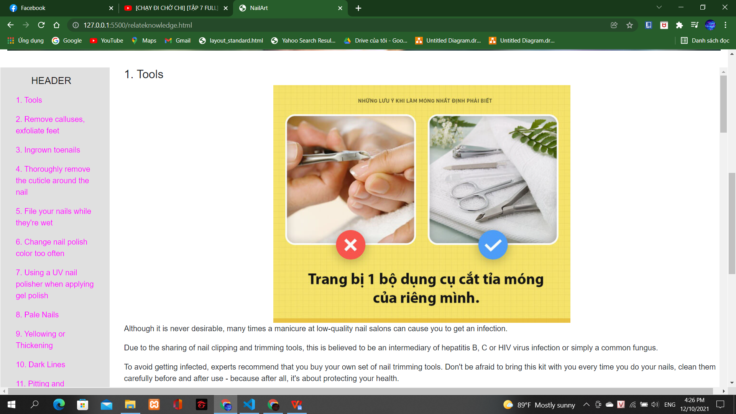

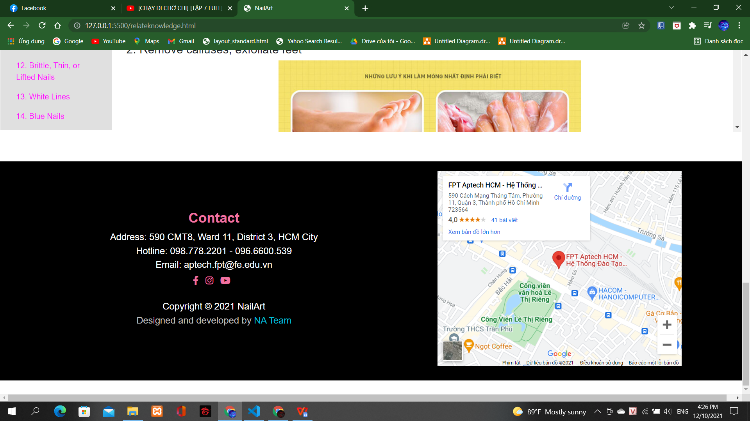

**Product page:**

Description:

This website displays the following information: Maps and Contacts, and Nail Industry Related Products.

Screenshoot

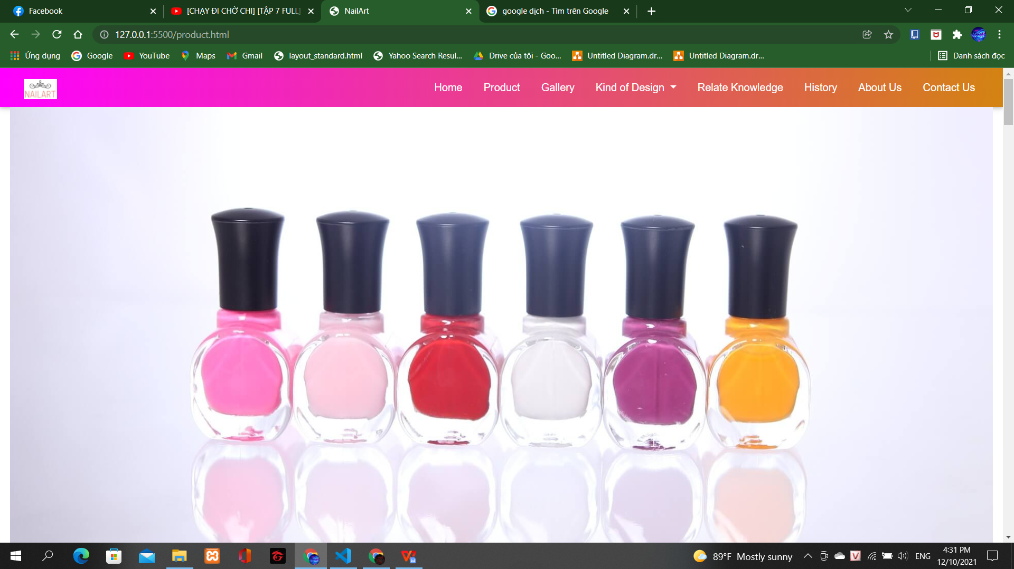

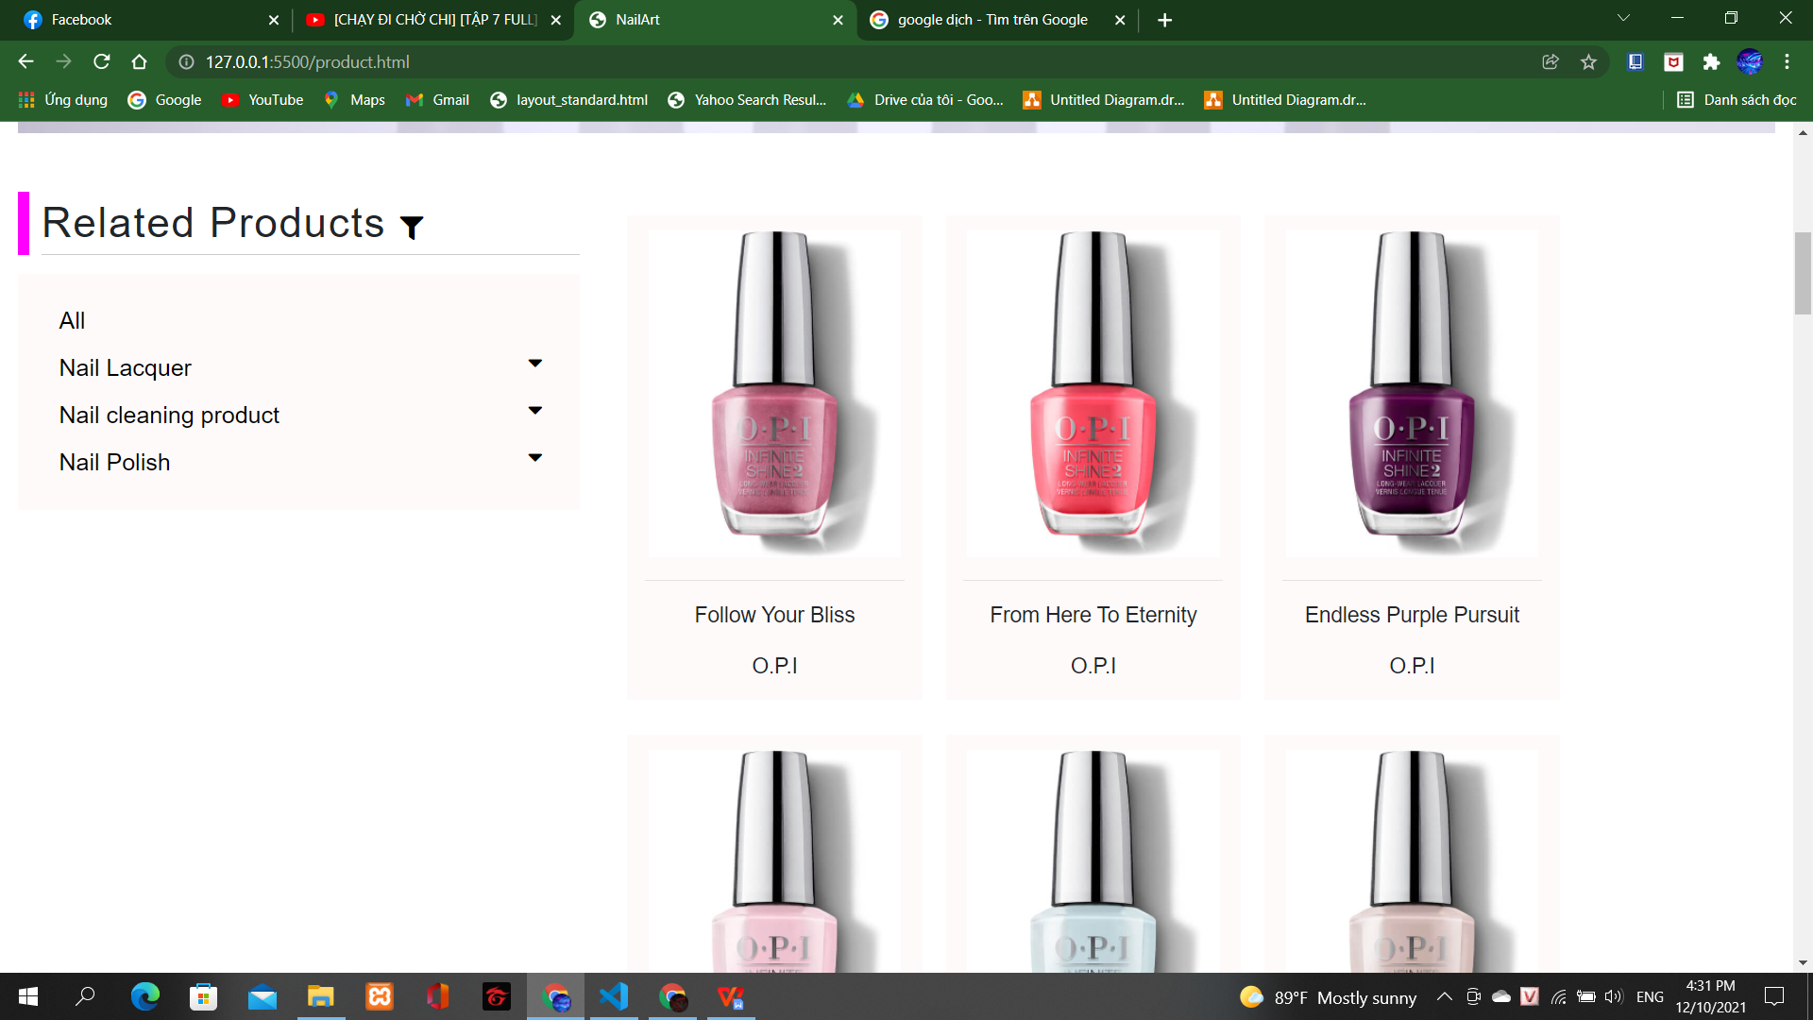

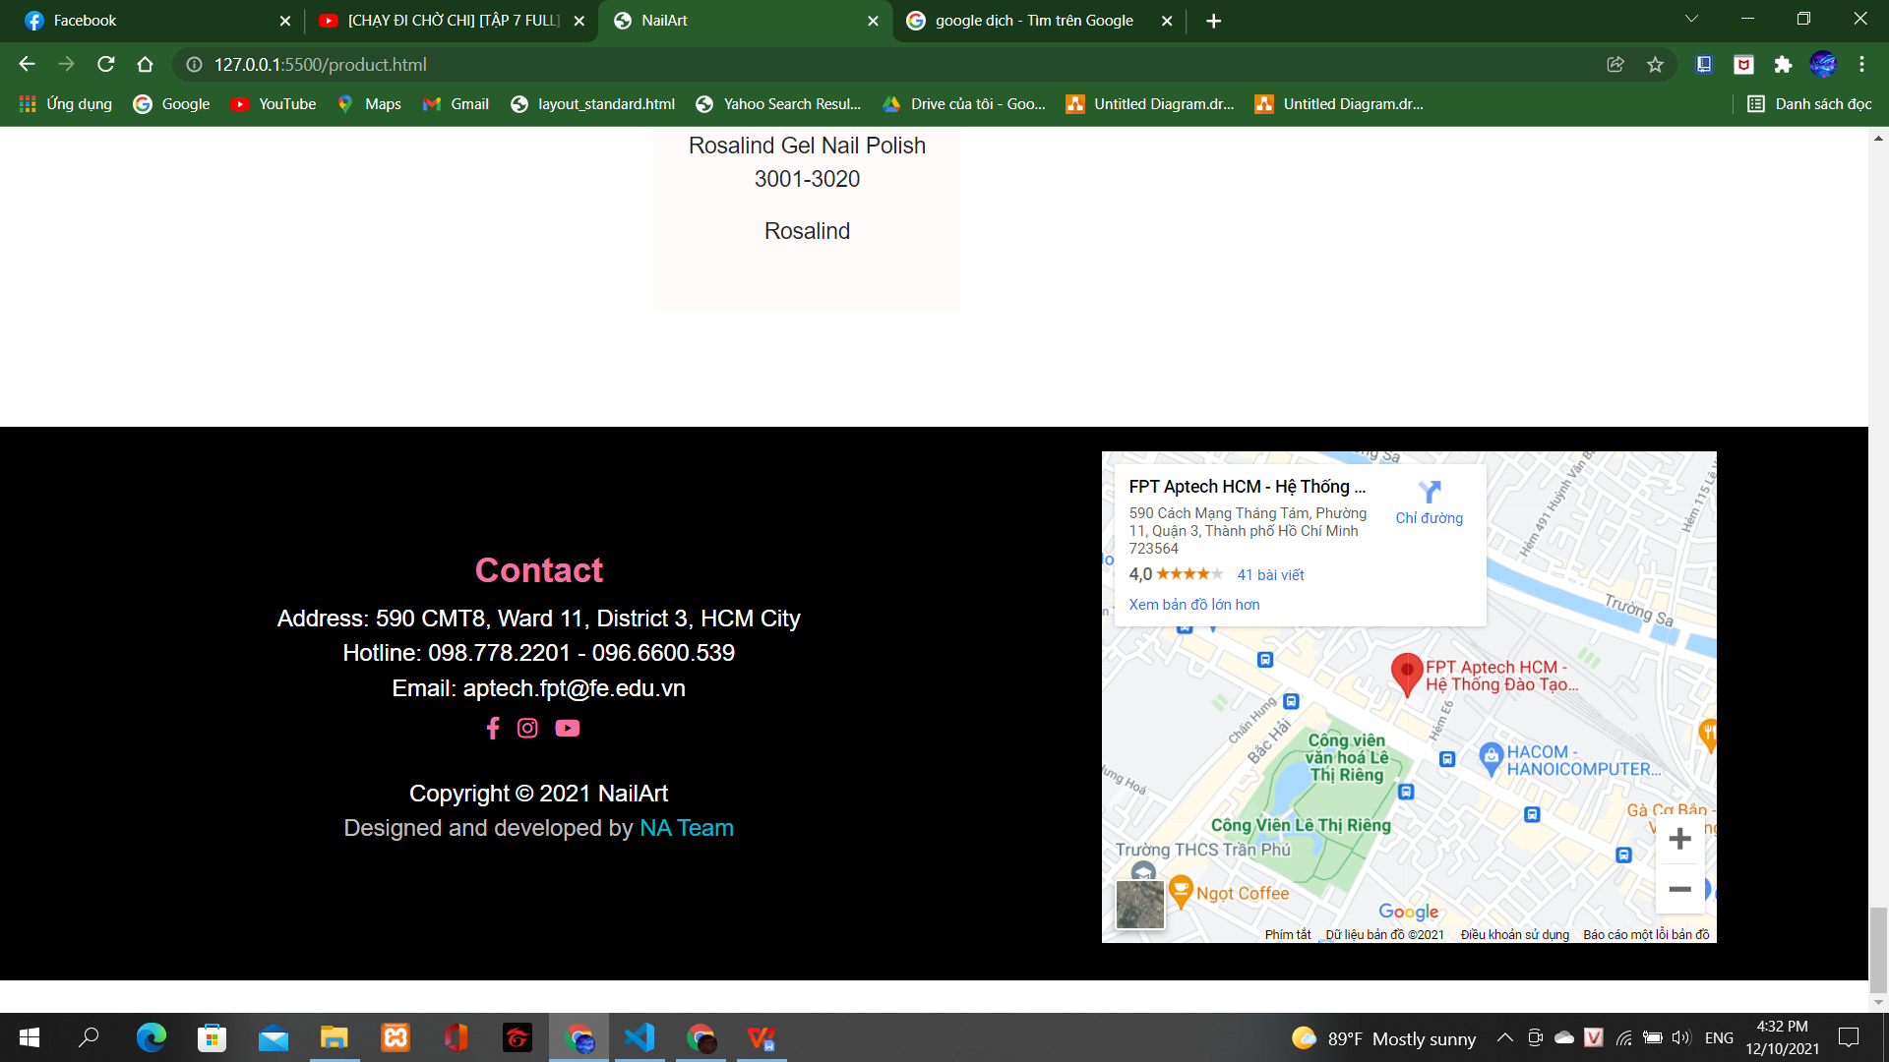

**Kind of design (kids):**

Description:

This website displays the following information: Maps and Contacts, Children's Favorite Nail Art Patterns, how to make a nail design, and more.

Screenshoot

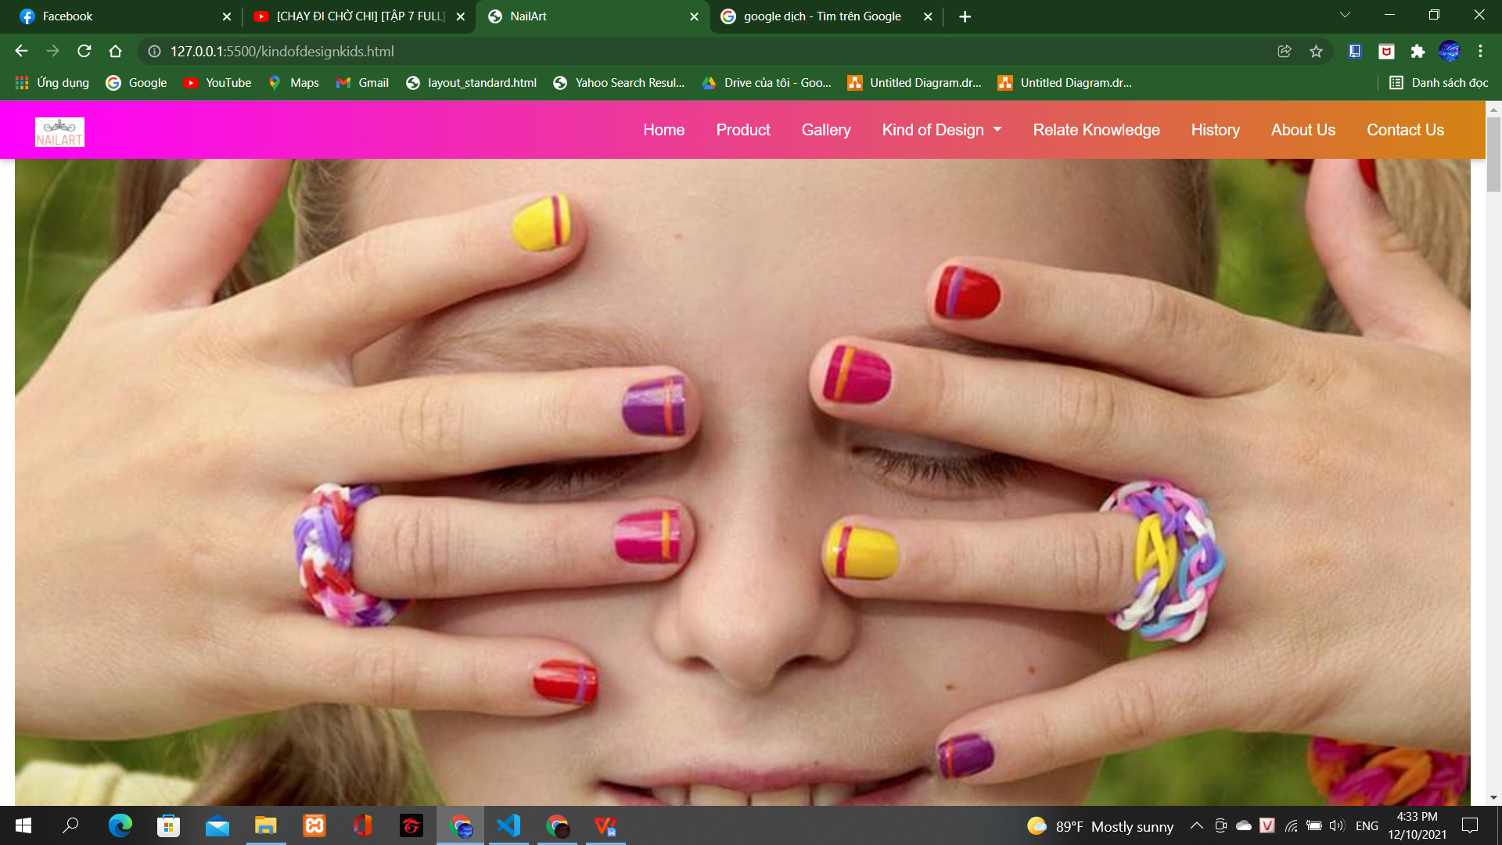

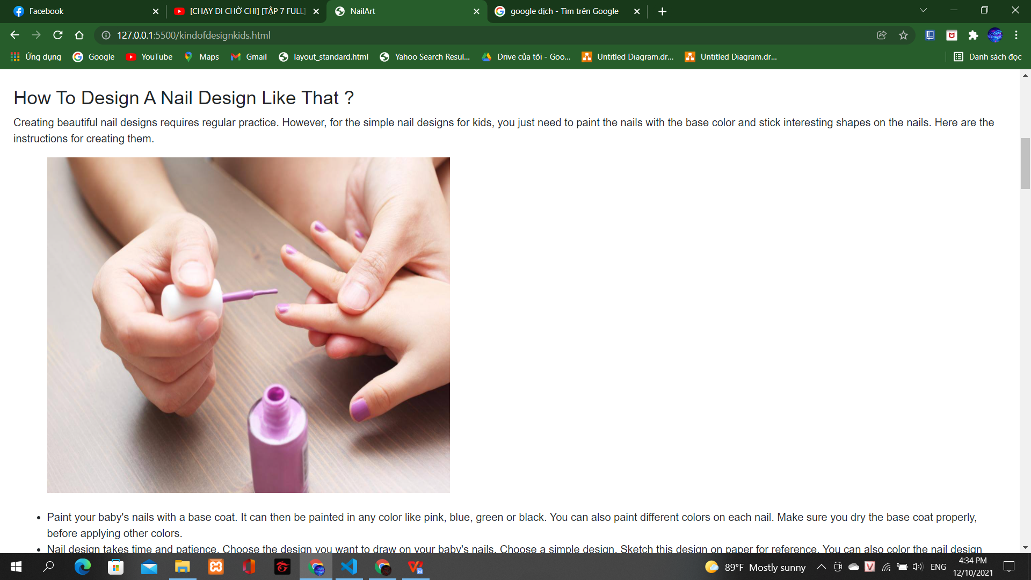

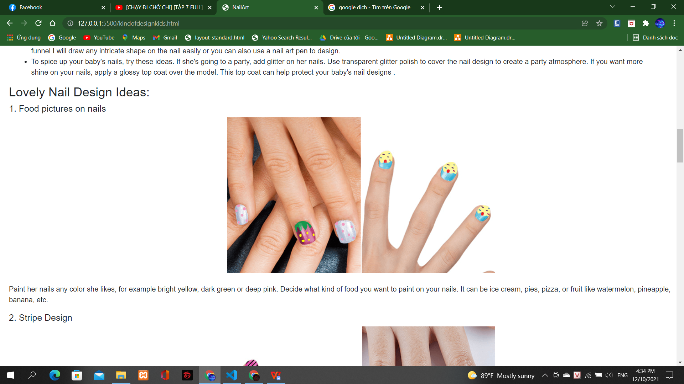

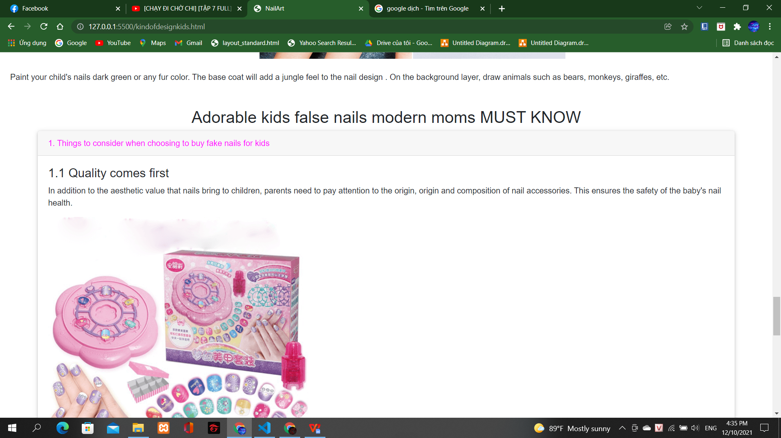

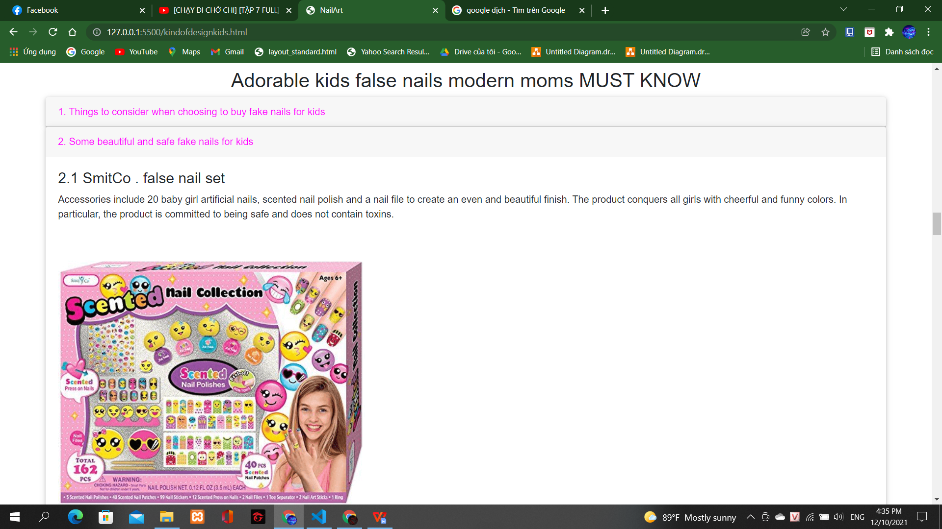

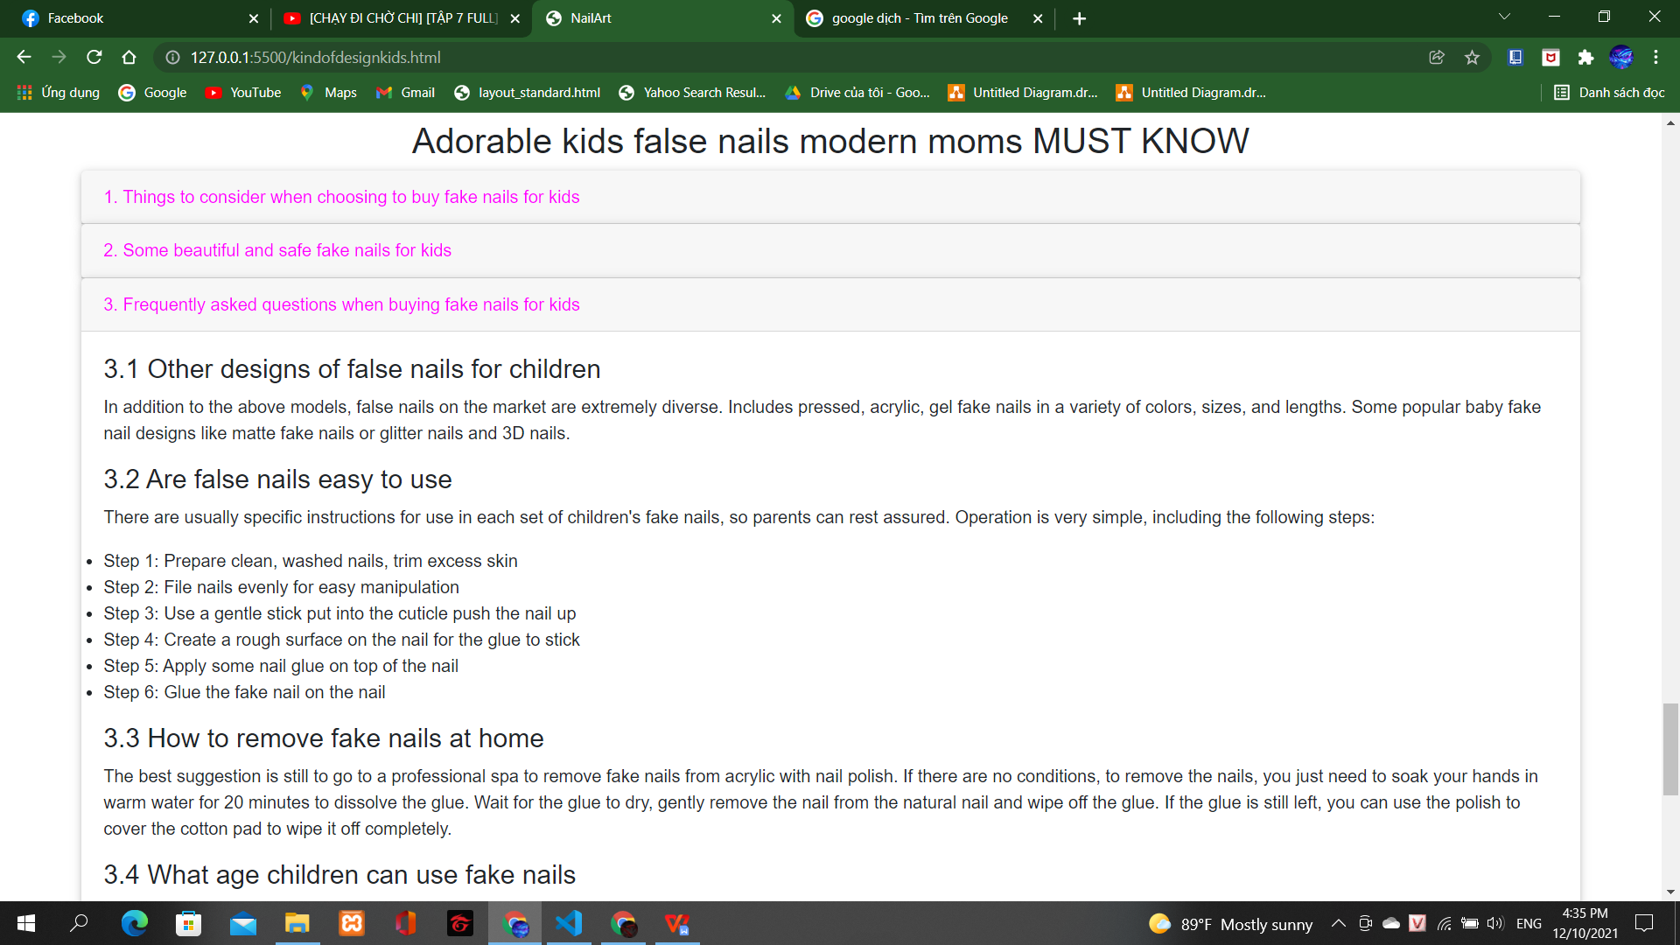

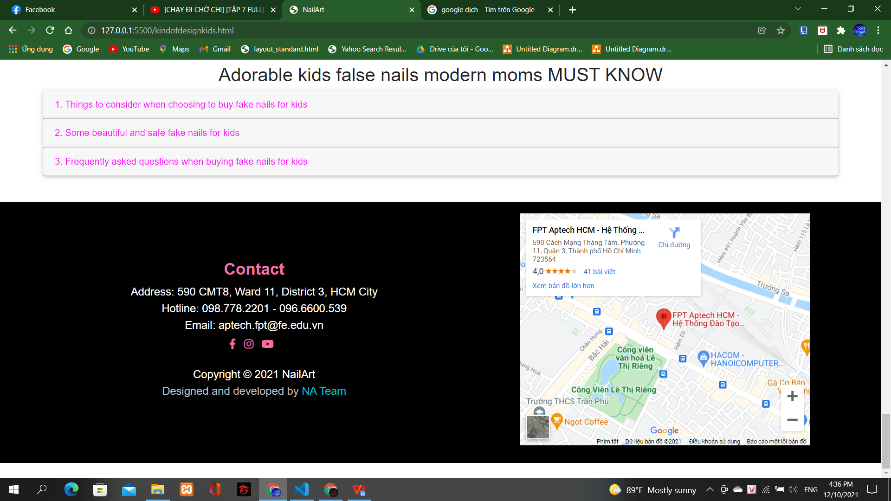

Kind of design (adults):

Description:

This website displays the following information: Map and Contacts, and 20 popular nail designs today.

Screenshoot

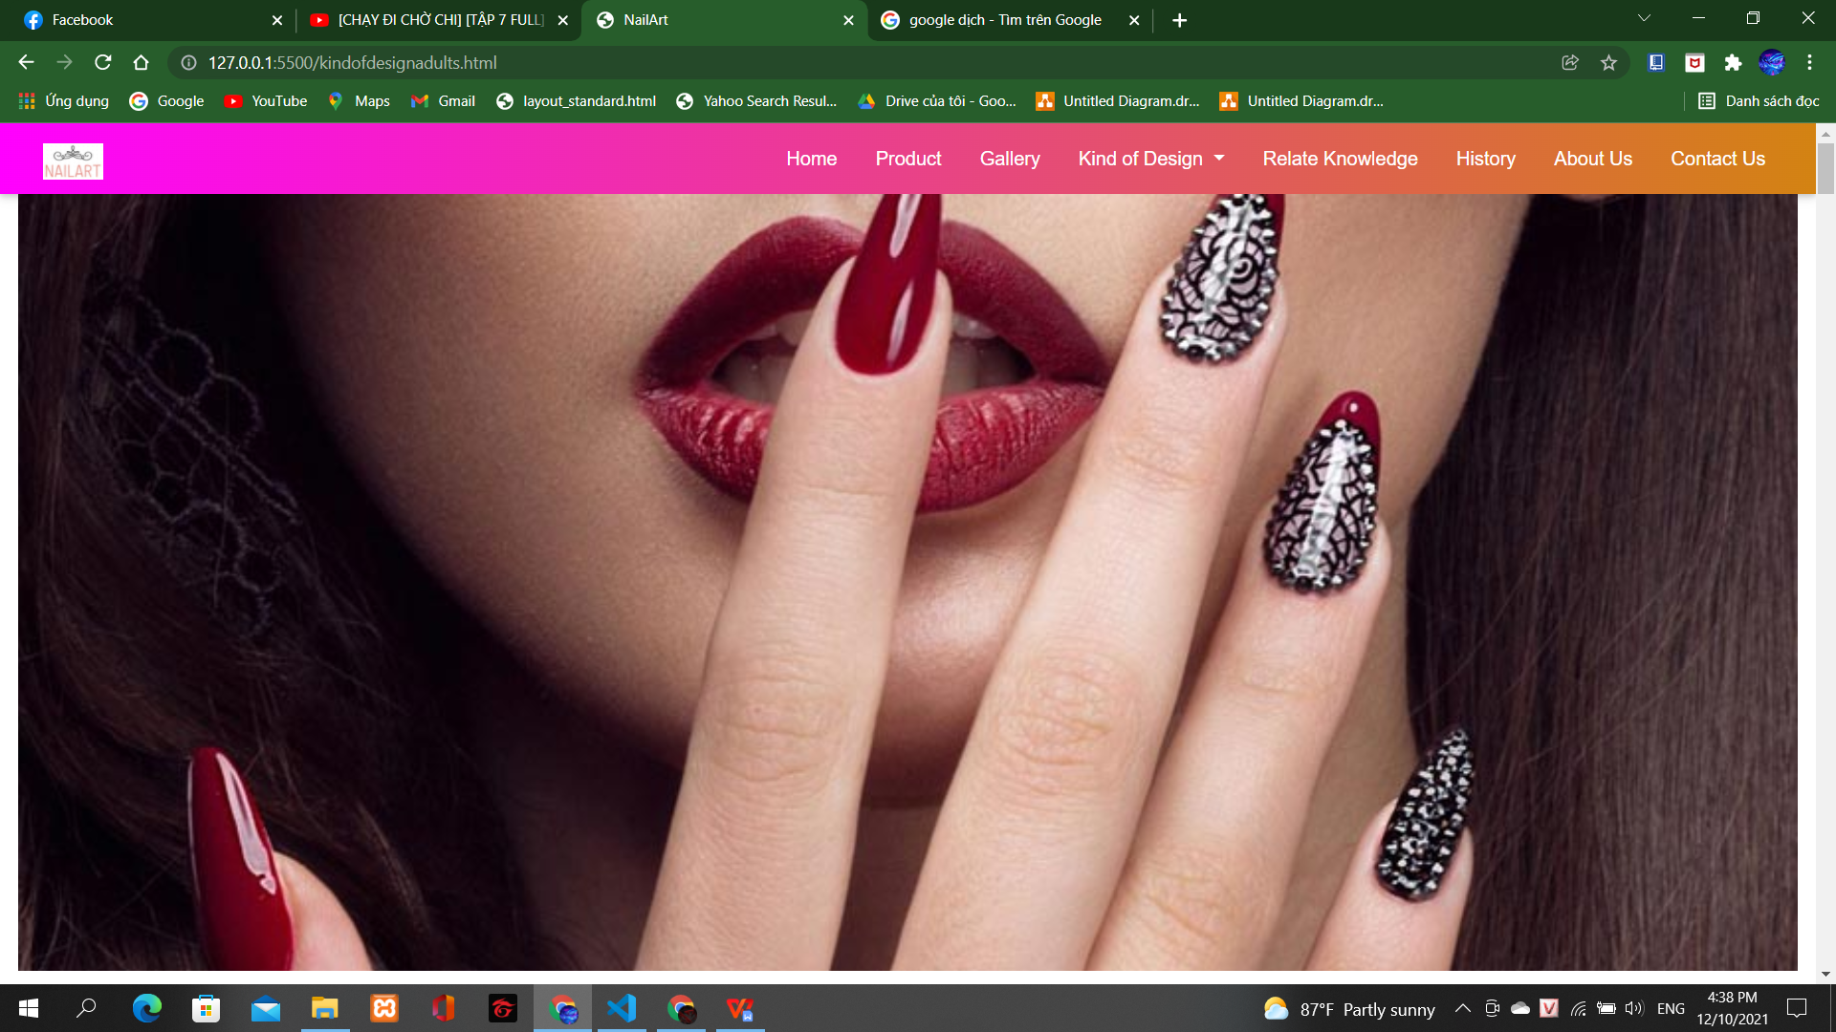

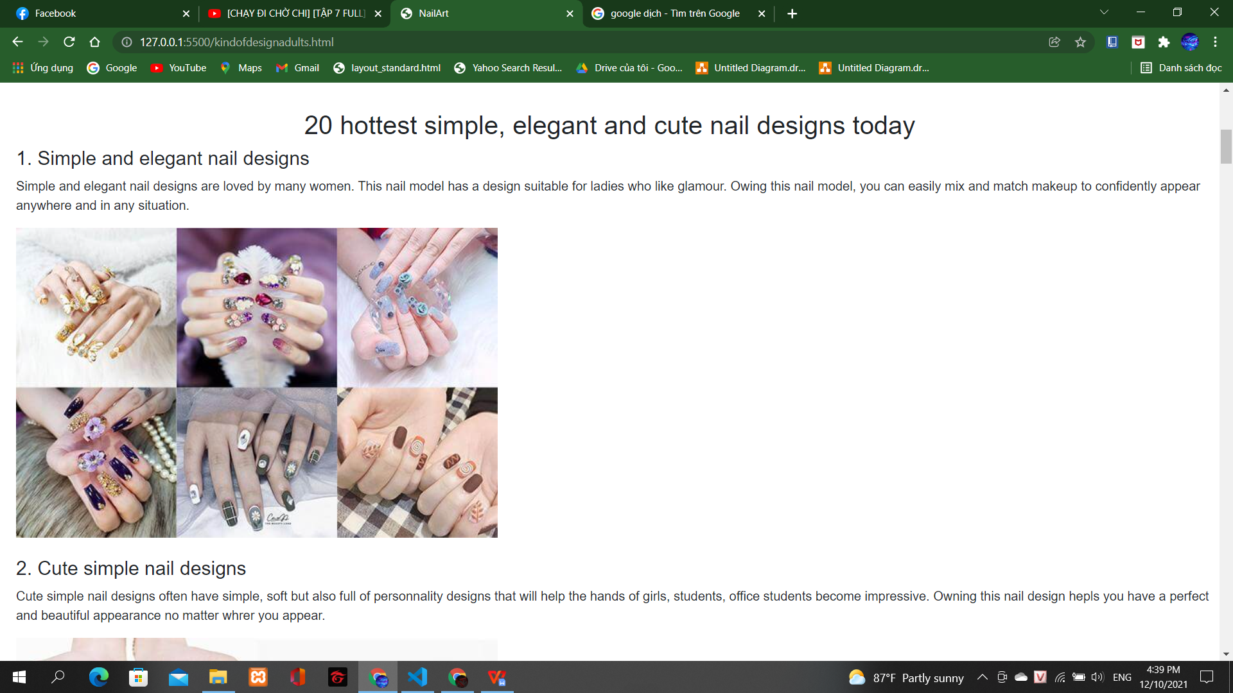

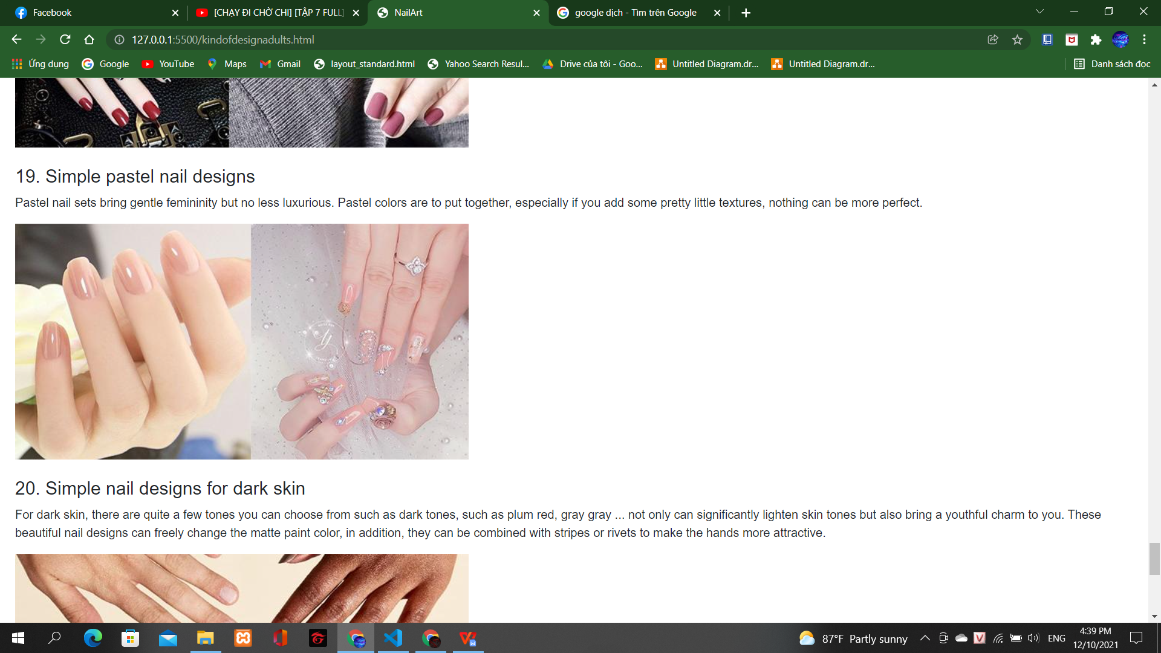

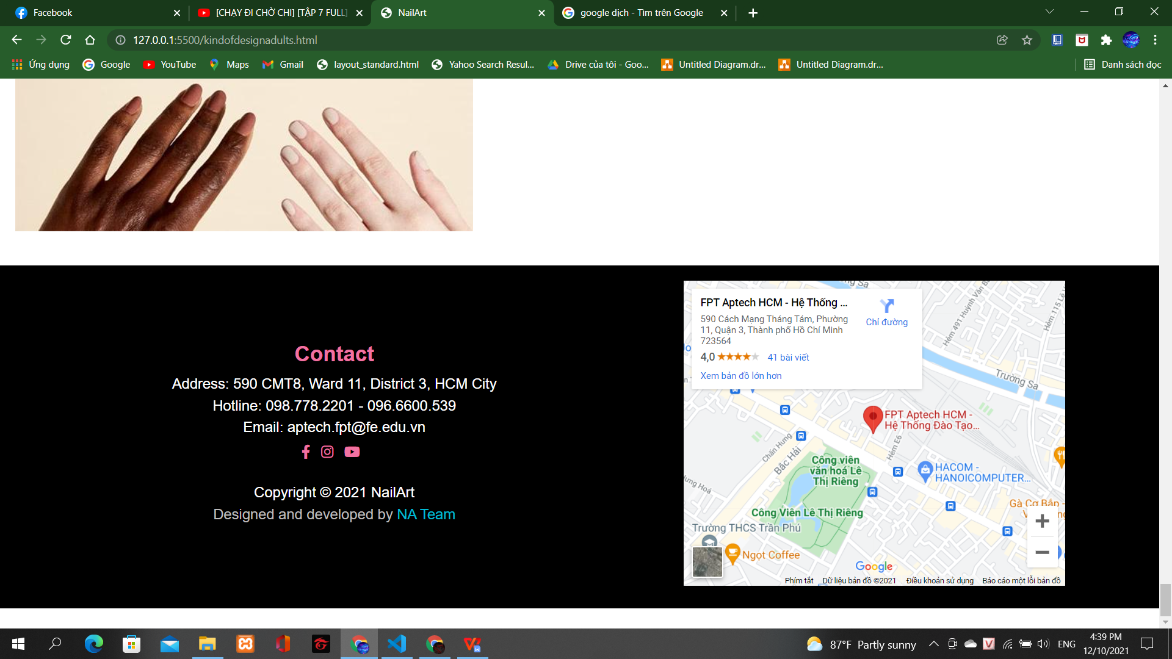

# TASK SHEET REVIEW 3

|  |  |  |  |  |  |  |  |
| --- | --- | --- | --- | --- | --- | --- | --- |
| ***Project Ref. No.:***  ***eP/Advertisement Portal Management System/01*** | | ***Project Title:*** | ***Activity Plan Prepared By:*** | ***Date of Preparation of Activity Plan:*** | | | |
| ***Sr.***  ***No.*** | ***Task*** | ***Actual Start***  ***Date*** | ***Actual Days*** | ***Team Mate***  ***Names*** | ***Status*** |
| *1* | *Home page* | *NailArt* | *Nguyen Hoang Quan* | *30-11-2021* | *3* | *Quan* | *Completed* |
| *2* | *Gallery page* | *01-12-2021* | *1* | *Quan* | *Completed* |
| *3* | *History page* | *30-11-2021* | *3* | *Quan* | *Completed* |
| *4* | *About Us page* | *01-12-2021* | *1* | *Quan* | *Completed* |
| *5* | *Contact Us page* | *01-12-2021* | *1* | *Quan* | *Completed* |
| *6* | *Product page* |  |  | *Quan* | *Not yet* |
| *7* | *Kind of Design page* |  |  | *Truong* | *Not yet* |
| *8* | *Relate knowledge page* |  |  | *Truong* | *Not yet* |
| *9* | *Javascrip* |  |  |  |  | *Quan* | *Not yet* |
| *10* | *Check & fix code* |  |  |  |  | *Quan +*  *Truong* | *Not yet* |
| *11* |  |  |  |  |  |  |  |
| *12* |  |  |  |  |  |  |  |

|  |  |
| --- | --- |
| **Date: 01-12-2021** | |
| Signature of Instructor:  **Ms. Le Mong Thuy** | Signature of Team Leader:  **Nguyen Hoang Quan** |